**Supplementary Material**

Dataset S1. (A) Salp video specimens analyzed with video specifications, as well as mean morphological and kinematic attributes. (B) Salp specimens used in the respirometry experiments with mean physiological attributes. (Please see attached file.)

Table S1. Summary of numbers of specimens (N), number of measurements (n), and descriptive variable averages per species including both the video speed data and the respiration experiments data.

|  |  |  |  |  |  |  |  |  |  |  |  |  |
| --- | --- | --- | --- | --- | --- | --- | --- | --- | --- | --- | --- | --- |
|  | | **Speed Measurements from Videos** | | | | | | **Respiration Measurements from Experiments** | | | | |
| **Species** | **Architecture** | **Mean Number of zooids** | **Mean zooid length (mm)** | **Mean Pulsation rate (pulses/s)** | **Mean swimming speed (mm/s)** | **N** | **n** | **Mean Number of zooids** | **Mean zooid length (mm)** | **Mean Colony volume (ml)** | **N** | **n** |
| ***Brooksia rostrata*** | Bipinnate | 26 | 7.4 | 2.6 | 34.4 | 5 | 45 | 20.3 | 6.5 | 3.7 | 16 | 130 |
| ***Ritteriella amboinensis*** | Bipinnate | 18 | 25.6 | 1.9 | 42.5 | 9 | 77 | 12.7 | 22.1 | 8.0 | 7 | 44 |
| ***Ritteriella sp.*** | Bipinnate | 33 | 21.3 | 1.3 | 43.1 | 3 | 49 | 18.7 | 34.5 | 22.5 | 6 | 42 |
| ***Cyclosalpa polae*** | Cluster | 5 | 17.2 | 1.2 | 47.6 | 2 | 19 | 7.0 | 20.0 | 4.3 | 7 | 55 |
| ***Cyclosalpa sewelli*** | Cluster | 7 | 15.0 | 1.4 | 26.8 | 6 | 52 | 6.2 | 19.4 | 7.2 | 11 | 88 |
| ***Helicosalpa virgula*** | Helical | 60 | 11.5 | 3.3 | 49.9 | 1 | 7 | 66.0 | 14.0 | 14.8 | 2 | 13 |
| ***Iasis cylindrica*** | Linear | 43 | 8.9 | 3.6 | 61.1 | 32 | 308 | 26.8 | 10.5 | 6.5 | 15 | 103 |
| ***Ihlea punctata*** | Linear | NA | NA | NA | NA | 0 | 0 | 68 | 12 | 3.7 | 1 | 7 |
| ***Metcalfina hexagona*** | Linear | 18 | 26.8 | 2.4 | 109.6 | 9 | 105 | 16.0 | 28.0 | 22.0 | 1 | 7 |
| ***Salpa aspera*** | Linear | 9 | 28.3 | 2.1 | 114.3 | 7 | 57 | 16.2 | 32.0 | 9.1 | 6 | 42 |
| ***Salpa fusiformis*** | Linear | 16 | 17.2 | 3.0 | 57.2 | 8 | 74 | 13.0 | 17.7 | 2.1 | 7 | 47 |
| ***Salpa maxima*** | Linear | 2 | 61.6 | 0.7 | 55.9 | 4 | 34 | 3.6 | 87.8 | 27.8 | 8 | 52 |
| ***Soestia zonaria*** | Linear | 11 | 13.7 | 1.9 | 109.2 | 4 | 34 | 9.1 | 19.6 | 4.6 | 8 | 23 |
| ***Thalia sp.*** | Oblique | 29 | 3.5 | 4.5 | 5.8 | 1 | 28 | 18.6 | 5.9 | 0.3 | 7 | 53 |
| ***Pegea sp.*** | Transversal | 12 | 31.0 | 1.7 | 20.3 | 2 | 18 | 13.1 | 43.2 | 29.2 | 13 | 91 |
| ***Cyclosalpa affinis*** | Whorl | 5 | 33.0 | 1.4 | 24.5 | 2 | 15 | 6.7 | 37.9 | 23.4 | 10 | 65 |
| ***Cyclosalpa bakeri*** | Whorl | 7 | 7.0 | 2.6 | 10.4 | 7 | 63 | 6.9 | 14.6 | 3.0 | 7 | 57 |
| ***Cyclosalpa quadriluminis*** | Whorl | 8 | 27.1 | 1.3 | 25.3 | 1 | 6 | 8.3 | 24.5 | 12.7 | 6 | 36 |

Table S2. Tukey’s post-hoc pairwise comparisons from an ANOVA on (A) swimming speed and (B) COT across different colonial architectures reporting magnitude of difference and adjusted p-values.

**A.**

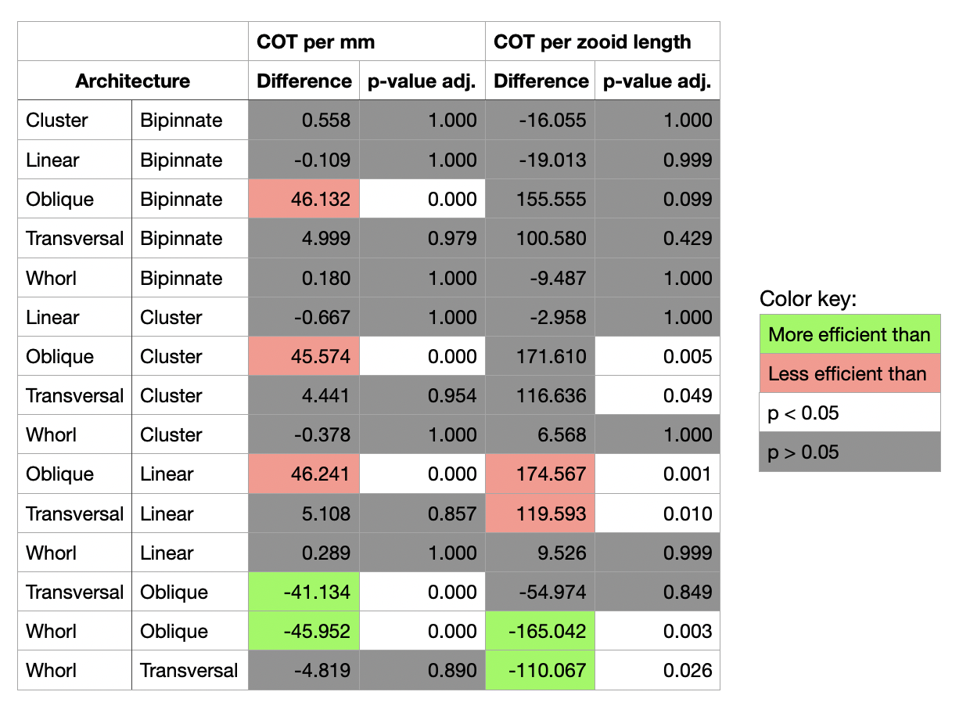

**B.**

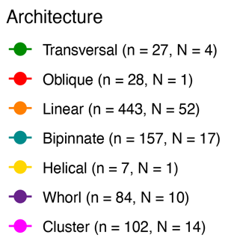

**D.**

**C.**

Figure S1. Salp swimming speeds. Distribution of salp colony absolute (A) and zooid size-corrected (B) swimming speed across pulsation rates. Distribution of salp colony absolute (C) and pulsation rate-corrected (D) swimming speed (specimen means with standard errors) across zooid sizes. Lines represent linear regressions with a 95% confidence interval shaded in grey.

**A.**

**B.**

Figure S2. Respiration rates across salp species. (A) Biovolume-normalized respiration rates of swimming (red) and anesthetized (blue) salp colonies across different species. (B) Percentage of the swimming respiration rates matched by the mean anesthetized respiration rate for each salp species. Bars represent species means with black lines representing standard errors. Colors indicate colonial architecture.

**D.**

**C.**

Figure S3. Proportion of metabolic cost spent on swimming. (A and B) Cost of transport (per mm in A, per zooid length in B) for each salp species across their percent swimming respiration rate matched by the species' mean anesthetized respiration rate. (C and D) Swimming speed (in mm/s in A, and zooids/s in B) for each salp species across their percent swimming respiration rate matched by the species mean anesthetized respiration rate. Point color indicates colonial architecture.